EXPT NO:6C | DATA VISUALIZATION USING POWER BI

Aim:
To clean, preprocess, and transform the raw ocean pollution dataset, load the clean data model into Power BI, and build an interactive visual dashboard to analyze booking trends, cancellation patterns, guest demographics, and pricing metrics.
Algorithm:
- Import Dataset: Load Ocean_Pollution_Dataset.csv into Power BI.
- Deduplication: Identify and remove duplicate rows across all fields.
- Check Missing Values: Identify missing/null values in the dataset.
- Impute Missing Values:
Replace missing numerical values with the median.
Replace missing Ocean and Country values with the mode.
- Handle Data Type & Syntax Errors:
Ensure Year is Whole Number, Affected_Marine_Species is Whole Number, and pollution/cost columns are Decimal Number.
Remove or correct negative/invalid values.
- Create Total Pollution:
Add a Custom Column in Power Query:
Total_Pollution = Plastic_Waste_Tonnes + Oil_Spill_Tonnes + Marine_Debris_Tonnes
- Load Clean Data: Click Apply & Close to load the cleaned data into Power BI Desktop.
- Create Core Metric:
Right-click the table → New Measure.
Define:
Total Pollution = SUM(Ocean_Pollution[Total_Pollution])

Output:

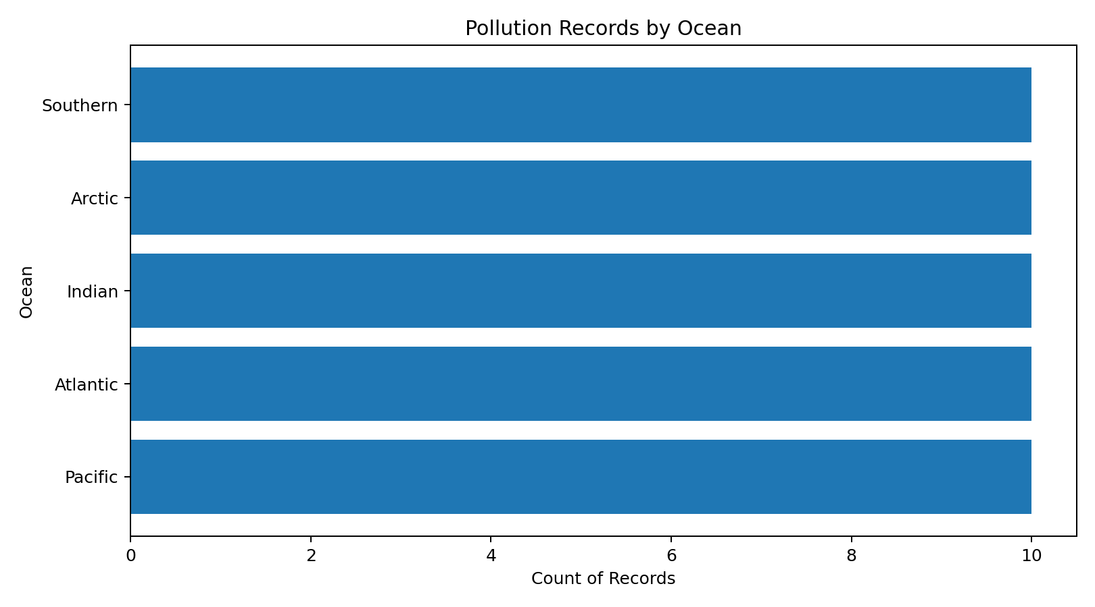

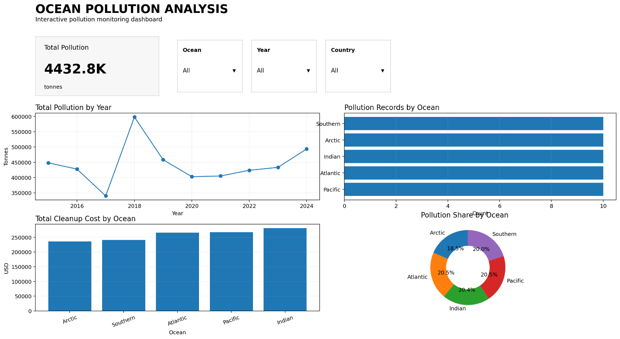

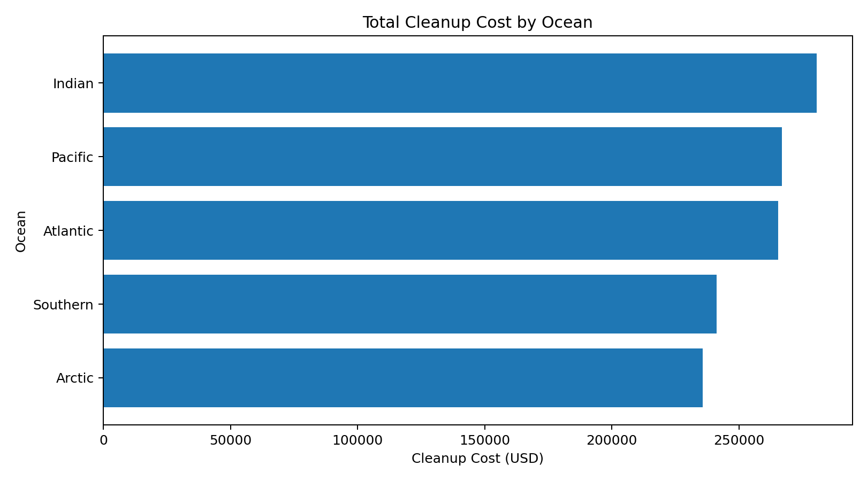

Result:

